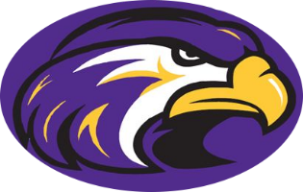

Holly Springs High School
Curriculum Fair
Thursday, February 16, 2017

Come learn more about Holly Springs High School’s wide variety of course and club offerings at our annual Curriculum Fair. Attend a special presentation for rising freshman, visit departmental displays and explore all the opportunities available through our robust Advanced Placement Program.

Floating Curriculum Fair
Current Students: 5:00-6:00
Rising 9th Graders: 6:00-7:30
Commons, Gym, Media Center

Information Session for Rising 9th Graders
5:30-6:00 OR 7:00-7:30
Auditorium

Vision 2020: By 2020, WCPSS will annually graduate at least 95% of its students ready for productive citizenship as well as higher education or a career.

